**Assignment-4 ( 5 marks)**

Instructions:

**Create below page .**

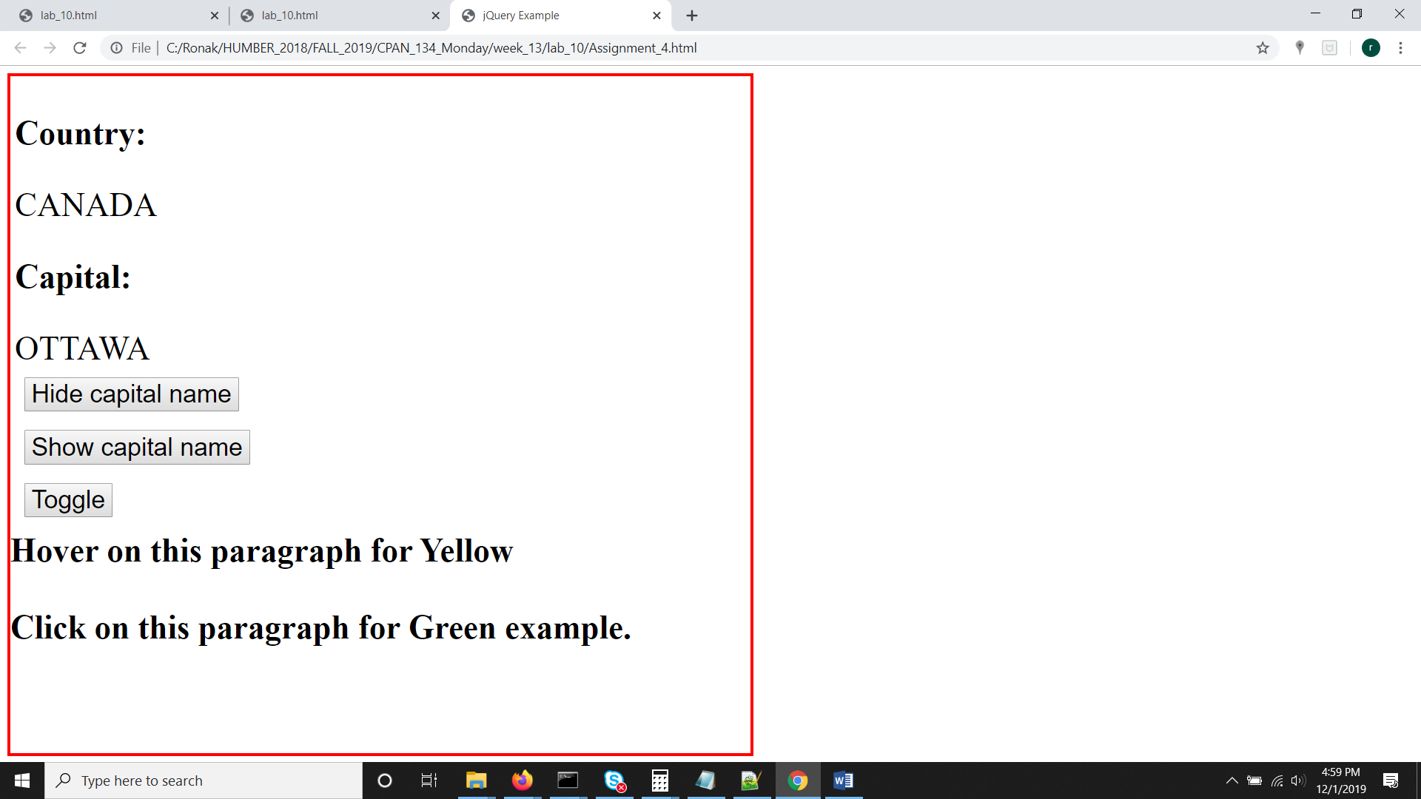

Instructions

1. When you click on “Hide capital name”, Ottawa should be hidden
2. When you click on “Show capital name”, Ottawa should be shown
3. When you click on “Toggle”, Ottawa should be hidden or shown.
4. **the lower part of the page should have the following behavior**
5. **Hovering** on the first paragraph would change the background color to yellow
6. **Clicking the** second paragraph would change the background color to green